**Art - Year 4**

Autumn Term – Sketching

**Art links**

Explore the differences and similarities within the work of artists, craftspeople and designers in different times and cultures (Y2)

Experiment with different grades of pencil and implements (Y3)

Geography links:

Sketch maps are simple drawings of the landscape (Y4)

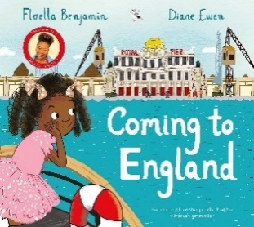**English links:**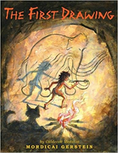



Heritage