**Art - Year 4**

Summer Term – Michelangelo/Sculptures

**Art links**

A sculpture is an art form made in three dimensions (Y1)

Understand basic use of a sketchbook and work out ideas for drawings (Y2)

Annotate work in a sketchbook (Y2)

Plan, design and make models (Y3)

Construct a simple clay base for extending and modelling other shapes (Y3)

Join clay adequately and work reasonably independently (Y3)

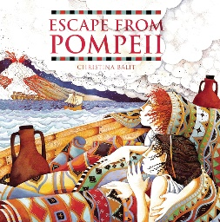**English links:**



Experiences