**Art - Year 5**

Spring Term – Stephen Wiltshire

**Art links**

Understand the basic use of sketchbook and work out ideas for drawing (Y2)

Select and record from first hand observation, experience and imagination and explore ideas for different purposes (y4)

Alter and refine drawings and describe changes using art vocabulary (Y4)

Collect images and information independently in a sketchbook (Y4)

Se

**English links:**

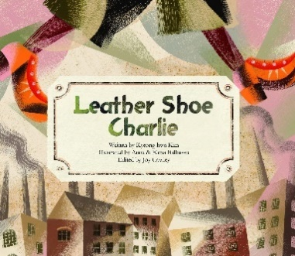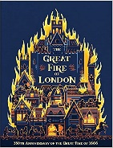

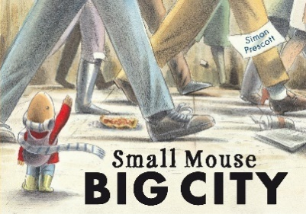

Heritage