**Art - Year 2**

Summer Term - Ann Steer - Nature sculptures

Seascapes

**Art links**

A seascape is a picture representing a scene at sea (Y1)

A sculpture is an art form in three dimensions (Y1)

Explore the differences and similarities within the work or artists, craftspeople and designers in different times and cultures (Y1)

Create images from imagination, experience or observation (Y1)

**Geography links**

The five oceans are Arctic, Atlantic, Indian, Pacific and Southern (Y1)

**English Texts**

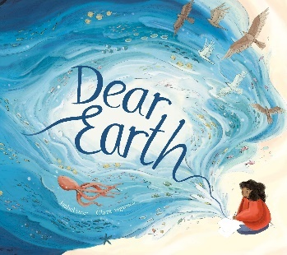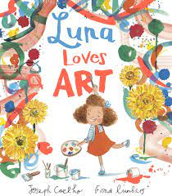



Experiences