**Art - Year 2**

Spring Term – Local area art: Cityscapes

Mick Manning

**Geography links**

Use relative vocabulary (e.g. bigger/smaller, like/dislike)

**Art links**

Use a sketchbook to gather and collect artwork (Y1)

Begin to explore the use of line, shape and colour (Y1)

Carry out different printing techniques e.g. monoprint, block, relief and resist printing (Y1)

**English Texts**

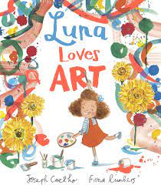



Heritage