**Art - Year 5**

Summer Term – L.S Lowry

**Art links**

Plan, refine and alter their drawings as necessary (Y3)

Make informed choices about the 3D technique chosen (Y4)

Construct a simple clay base for extending and modelling other shapes (Y4)

Join clay adequately and work reasonably independently (Y4)

Extend their work within a specified techniques (Y5)

Se

**Geography links:**

The top 5 biggest cities in the UK

**English links:**

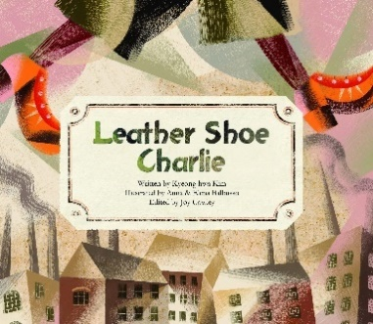



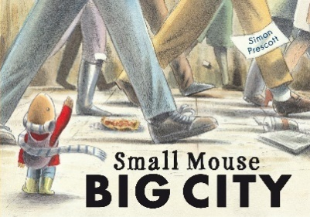

Experiences