**Art - Year 6**

Spring Term – Claude Monet

Papier Mache

**Art links**

Make and match colours with increasing accuracy (Y4)

Choose paints and implements appropriately (Y4)

Plan, design, make and adopt models (Y4)

Demonstrate a secure knowledge about primary and secondary colours (Y5)

John Sargent is an American artist/watercolourist known for his landscapes and portraits (Y5)

**English links:**

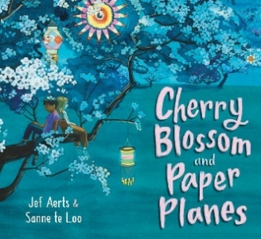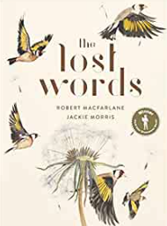



Experiences