**Art - Year 5**

Autumn Term – John Sargent/Georgia O’Keeffe

Watercolours/Oil pastels

**Geography links:**

Greece is one of the most mountainous countries in Europe (Y3)

**Art links**

Linda Mackey is a Canadian landscape artist (Y3)

Explore the roles and purposes of artists, craftspeople and designers working in different times and cultures (Y4)

Make and match colours with increasing accuracy (Y4)

Choose paints and implements appropriately (Y4)

Show increasing independence and creativity with the painting process (Y4)

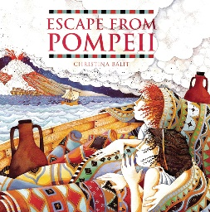**English links:**



Experiences