**Art - Year 4**

Spring Term – Paul Klee/Abstract art

**Art links**

Understand the basic use of a sketchbook and work out ideas for drawings (Y2)

Layer different media e.g. crayons, pastels, felt tips, charcoal and ballpoint (Y2)

Use different media to achieve variations in line, texture, tone, colour, shape and pattern (Y3)

Geography links:

There are 4 different capital cities in the United Kingdom which are: London – the capital of England, Edinburgh – the capital of Scotland, Cardiff – the capital of Wales and Belfast – the capital of Northern Ireland. (Y4)

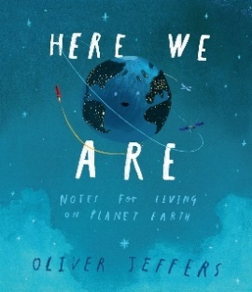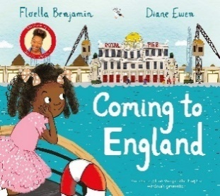**English links:**



Experiences