**Art - Year 6**

Autumn Term – Richard Eurich

**Art links**

Experiment with a range of media e.g. overlapping, layering etc. (Y3)

Plan and create different effects and textures with paint according to what they need for the task (Y4)

Use sketchbooks to develop ideas (Y5)

Extend their work within a specified techniques (Y5)

Investigate art, craft and design in the locality and in a variety or genres, styles and traditions (Y5)

Se

**Geography links:**

There are hundreds of landmarks in the UK. The oldest – Knap of Howar – was built in 3700BC (Y5)

**English links:**

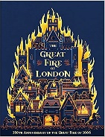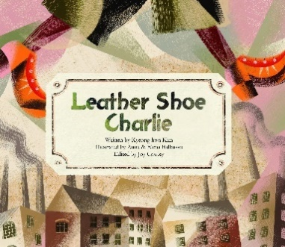



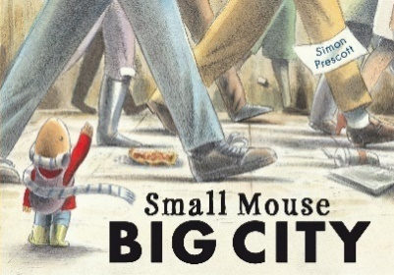

Heritage