**Design Technology - Year 6**

Autumn Term – Sturdy structures

History links:

Children know the features of a castle (Y1)

Children know about unique buildings in Bradford (heritage walks Y1 – 5)

When Salt’s Mill opened it was the largest mill in the world (Y4)

17th Century houses were made from timber, wattle and daub (Y4)

The upper storeys of some Tudor houses were bigger than the ground florr and would overhang (Y4)

**DT links**

Frame structures are structures that use beams and columns to support an outer shell (Y5)

Cut and join with accuracy to ensure a good quality finish to the product (Y5)

Measure and mark out accurately (Y5)

Children create a frame structure (Y5)

Science links:

Identify and compare the suitability of a variety of everyday materials including wood, metal, plastic, glass, brick, rock, paper and cardboard for particular uses (Y2)

**English links:**

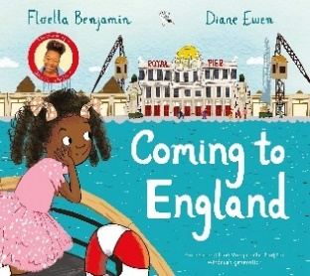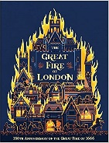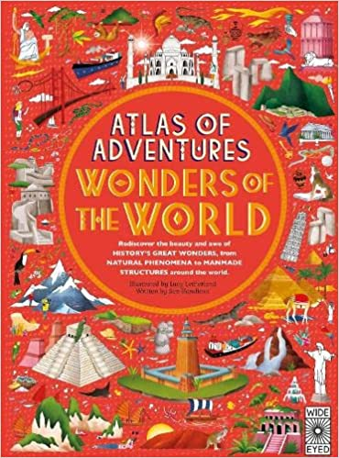

Experiences