**Design Technology - Year 2**

Autumn Term - Preparing a healthy snack

Flapjacks and seed bars

**Science links**

Flowers are made up of roots, stems, leaves and flowers. (Y1)

We have grown plants from seeds.  (Y1)

**DT links**

A fruit is a food that grows on plants and has a seed. (Y1)

A vegetable is a food that grows on plants but doesn’t have seeds. (Y1)

Foods have different tastes and textures. (Y1)

Eating healthily supports people to have more energy. (Y1)

**English Texts**

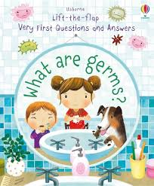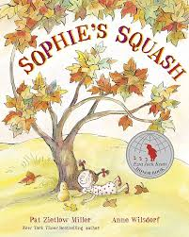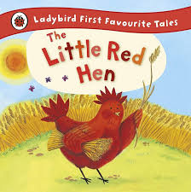

**Art links**

Explore the natural world around them, making observations and drawing pictures of animals and plants. (EYFS)

**PE links**

Staying healthy and active helps us to stay happy and improve our mental health. (Y1)

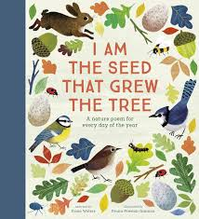



**Geography links**

The countries closer to the equator are warmer and the countries furthest away are the coldest. (Y1)

Healthy Lifestyles