**Design Technology - Year 5**

Summer Term – Combining textiles with art

Art links:

Demonstrate a secure knowledge about warm and cold, complementary and contrasting colours (Y5)

**DT links**

Fasteners are used to close textile products (Y4)

Join and combine materials and components accurately in temporary and permanent ways (Y4)

Measure, tape or pin, cut and join fabric with some accuracy (Y4)

Sew using a range of different stiches , weave and knit (Y4)

History links:

Our Magical City topic focussing on Salts Mill – (Y4)

**English links:**

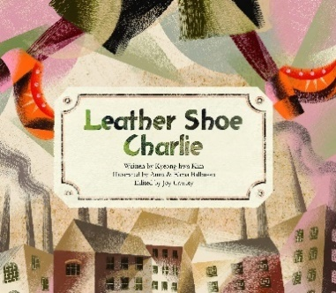

Experiences