**Design Technology - Year 4**

Spring Term – Simple electrical components

**DT links**

Make simple drawings and label parts (Y2)

Select tools and techniques for making their product (Y3)

Identify a purpose and establish criteria for a successful product (Y3)

**Science links**

Light comes from different sources (Y3)

Light is a form of energy that enables us to see the world around us (Y3)

A complete circuit is made up of different components – batteries (a cell) wires and bulbs, buzzers and motors (Y4)

Electricity can only travel if there is a complete circuit (Y4)

Recognise some common conductors and insulators, and associate metals with being good conductors (Y4)

Identify common appliances that run on electricity (Y4)

Construct a simple series electrical circuit, identifying and naming its basic parts, including cells, wires, bulbs, switches and buzzers Identify whether or not a lamp will light in a simple series circuit, based on whether or not the lamp is part of a complete loop with a battery (Y4)

Recognise that a switch opens and closes a circuit and associate this with whether or not a lamp lights in a simple series circuit (Y4)

**English links**

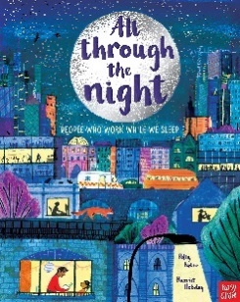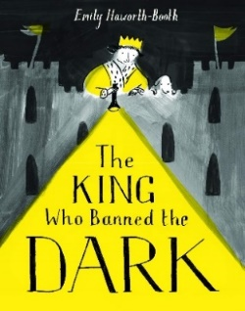



Experiences