**Geography - Year 6**

Summer Term – Settlements

**Geography links:**

Measure straight line distance on a plan (Y5)

Begin to use primary and secondary sources of evidence in their investigations (Y5)

Begin to use 4 figure co-ordinates to locate features on a map (Y5)

Begin to suggest questions for investigating (Y5)

**Maths links:**

Position and direction (Y5)

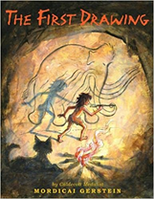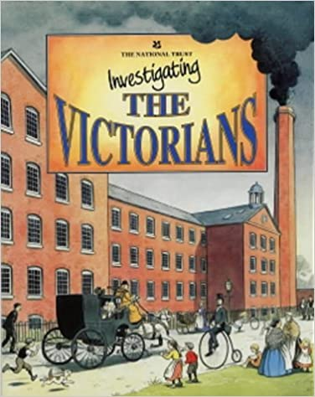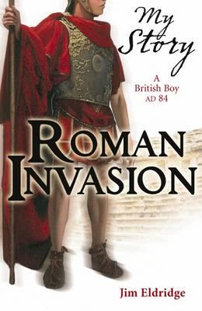**English links:**

Experiences