**Geography - Year 2**

Autumn Term – Continents of the world

**English Texts**

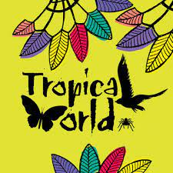  
  
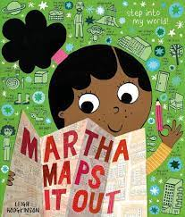

**Geography links**

The 5 oceans are Arctic, Atlantic, Indian, Pacific and Southern (Y1)

Find land/sea on a globe (Y1)

Learn names of some places within and around the UK (Y1)

Maths links

Position and direction (Y1)

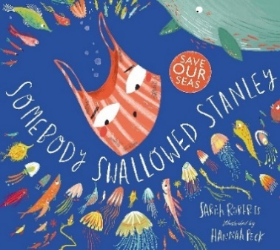

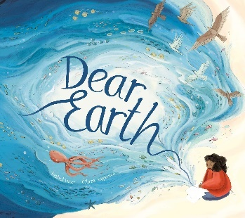

Aspirations