**Geography - Year 5**

Spring Term – UK Geography

**Geography links**

Collect and record evidence with some aid (Y4)

Use 4 compass points well (Y4)

Begin to use 8 compass points (Y4)

Use letter/no. co-ordinates to locate features on a map confidently (Y4)

Draw a sketch map from a high view point (Y4)

Begin to recognise symbols on an OS map (Y4)  
  
Use large and medium scale OS maps (Y4)

Investigate places and themes at more than one scale (Y4)

**Science links:**

Identify that most living things live in habitats to which they are suited and describe how different habitats provide for he basic needs of different kinds of animals and plants, and how they depend on each other (Y2)

Explore the requirements for plants for life and growth (air, light, water nutrients from the soil and room to grow) and how they vary from plant to plant (Y3)

**English links:**

****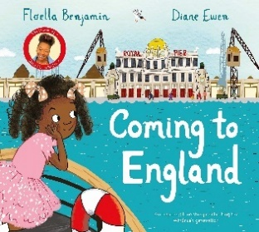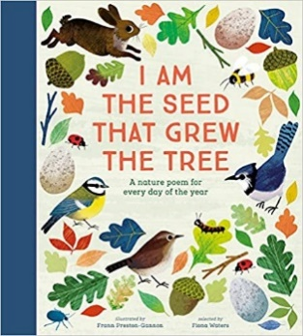

Heritage