**Geography - Year 5**

Summer Term – Land use and settlements

**History links:**

Look at evidence available (Y4)

Begin to evaluate the usefulness of different sources (Y4)

**Geography links**

Ask and respond to questions and offer their own ideas (Y4)

Collect and record evidence with some aid (Y4)

Salts Mill is built on a canal that connects Saltaire to Leeds and Liverpool (Y4)

**English links:**

****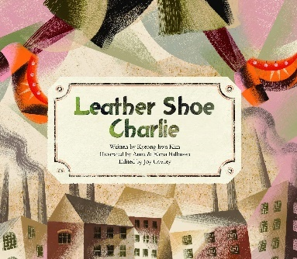

Experiences