**Geography - Year 2**

Summer Term – Seaside features and contrasting locations

**English Texts**

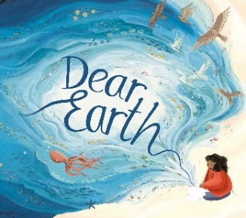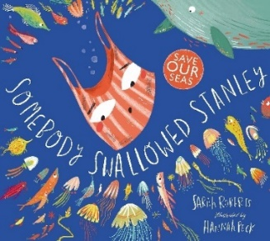

**Geography links**

Teacher led enquiries to ask and respond to simple closed questions (Y1)

Use relative vocabulary (Bigger/smaller, like/dislike) (Y1)

The imaginary line around the middle of the Earth is known as The Equator (Y1)

The countries closer to the equator are warmer and the countries further away are the coldest (Y1)

The seven continents are: Antarctica, North America, South America, Europe, Asia, Australia and Africa(Y2)

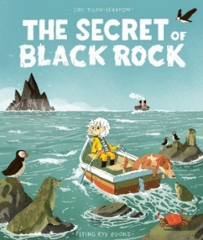



Experiences