**Geography - Year 5**

Autumn Term – Mountains

**Science links:**

There are three types of rock: sedimentary, igneous and metamorphic (Y3)

**Geography links**

Ask and respond to questions and offer their own ideas (Y4)

Use maps sites on the internet (Y4)

Use junior atlases (Y4)

**English links:**

****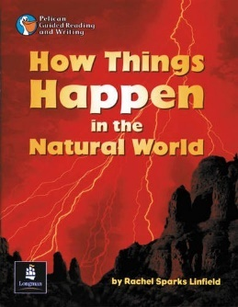

Experiences