**Geography - Year 3**

Spring Term – Latitude, longitude climate zones and biomes

**English Texts**

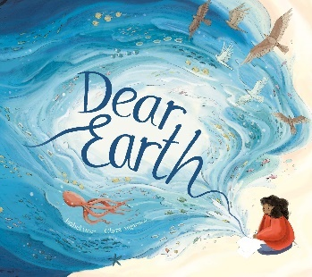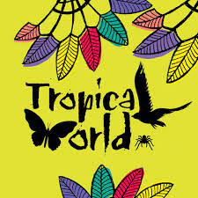

**Geography links**

The imaginary line around the middle of the Earth is known as the Equator (Y1)

Countries closer to the Equator are warmer and the countries further away are the coldest (Y1)

Make simple comparisons between features of different places (Y2)

**Science links:**

Identify and name a variety of common animals that are carnivores, herbivores and omnivores (Y1)

A habitat must provide food, shelter, water and space (Y2)

Different animals will require different things from their habitat (Y2)



Experiences