**History - Year 2**

Summer Term – Victorian Seaside

**History links**

Find answers to simple questions about the past from sources of information e.g. artefacts (Y1)

Know and recount episodes from stories about the past (Y1)

Queen Victoria’s reign is known as the Victorian era (Y1)

Recognise the difference between past and present in their own and others’ lives (Y1)

Compare adults talking about the past – how reliable are their memories? (Y1)

**Geography links**

Use information books/pictures as sources of information (Y1)

Investigate their surroundings (Y1)

**Art links**

A seascape is a picture representing a scene at sea (Y1)

**English links:**

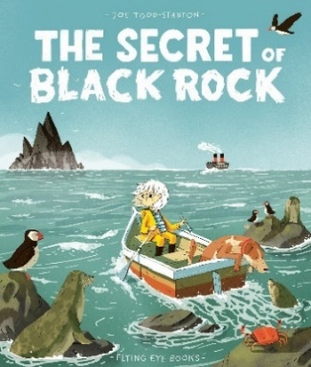



**Science links**

Summer is usually the hottest of the four seasons (Y1)

Experiences