**History - Year 2**

Autumn Term – The Wright brothers/Amelia Earhart

**History links**

Sequence 3 or 4 artefacts from distinctly different periods of time (Y1)

Know and recount episodes from stories about the past (Y1)

Distinguish between fact and fiction (Y1)

**Geography links**

Use information books/pictures as sources of information (Y1)

The five oceans of the world are Arctic, Atlantic, Indian, Pacific and Southern (Y1)

**English Texts:**

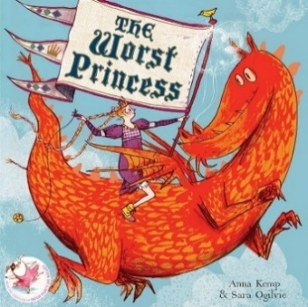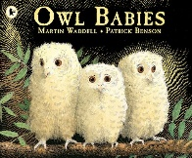



Aspirations