**History - Year 3**

Summer Term – Ancient Greece

**Geography links**

The countries closer to the equator are warmer and the countries further away are the coldest (Y1)

Use non-fiction books, stories, maps, pictures/photos and the internet as sources of information (Y2)

Make simple comparisons between features of different places (Y2)

The seven continents are: Antarctica, North America, South America, Europe, Asia, Australia and Africa (Y2)

Investigate their surroundings (Y2)

**History links**

Compare adults talking about the past – how reliable are their memories? (Y1)

Identify differences between ways of life at different times (Y2)

Use a source – observe or handle sources to answer questions about the past on the basis of simple observations (Y2)

Discuss reliability of photos/accounts/stories (Y2)

**English links:**

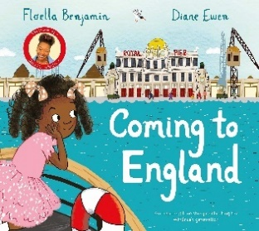



Experiences