**History - Year 4**

Autumn Term – Sir Titus Salt

**Geography links**

Bradford is located in West Yorkshire (Y2)

Use non-fiction books, stories, atlases pictures/photos and internet as sources of information (Y3)

**History links**

Queen Victoria’s reign is known as the Victorian era (Y1)

Identify reasons for and results of people’s actions (Y3)

Use a range of sources to find out about a period (Y3)

Identify and give reasons for different ways in which the past is represented (Y3)

**English links:**

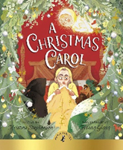



Heritage