**History - Year 5**

Summer Term – Victorian Britain

**History links**

Victoria would become the longest reigning British monarch and Queen of the biggest empire in history (Y1)

Queen Victoria’s reign is known as the Victorian era (Y1)

As the steam trains became more and more popular, people started going to the seaside for day trips, weekends and holidays (Y2)

Offer reasonable explanations for some events (Y4)

Look for links effects in time studies (Y4)

Choose relevant material to present a picture of one aspect of life in time past (Y4)

Recall, select and organise historical information (Y4)

Place events from period studies on a time line (Y4)

Understand complex term e.g. BC/AD (Y4)

**Geography links**

The UK is made up of four countries which are England, Ireland, Scotland and Wales (Y1)

Use non-fiction books, stories, atlases, pictures, photographs, and internet as sources of information (Y3)

Analyse evidence and draw conclusions e.g. make comparisons between locations, photographs, pictures and maps (Y4)

**English links:**

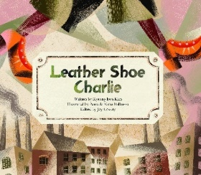

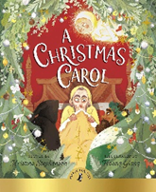

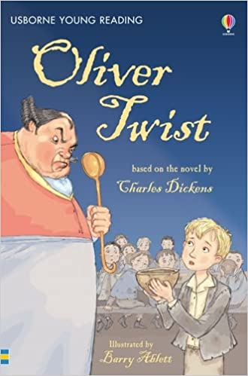

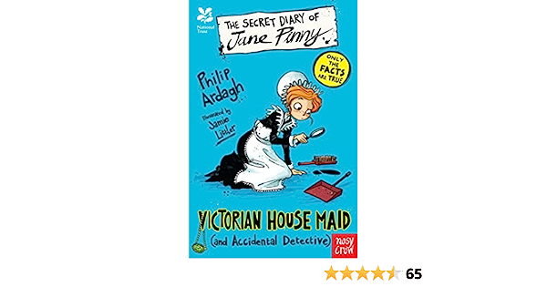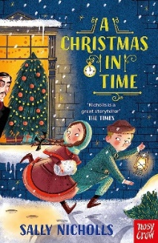



Heritage