Task Options
SCIENCE: Create a paper aeroplane that can overcome air resistance and stay in the air as long as possible. | SCIENCE: Draw a diagram including explanations to show the forces at work in a tug of war.
GEOGRAPHY: Look at famous landmarks in Athens and make a model of one of them. Here are some examples:  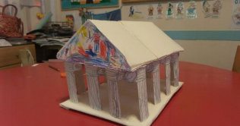  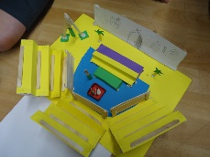 | GEOGRAPHY: Make a leaflet about Greece. You should include where it is, what the temperature is like and what things you can see there. You could do this on paper or on a computer.
DT: Write a set of instructions on how to make your favourite sandwich or wrap. Don’t forget to tell me the ingredients! | R.E: Design your own god or goddess. What would they be called? What would they represent?

