Year 4 Homework Autumn 1
Please complete a minimum of two tasks per half term. You may present your work in any way that you wish. We look forward to seeing some of your amazing creations! Have fun!

Task Options
SCIENCE: Make a model of the water cycle. | SCIENCE: Make a chart to show different uses of solids, liquids and gases in your home
History: Can you research and compare the life of a Victorian child to the life of a child today. | PE : Make a list of instructions showing how to play hockey.
MATHS: Can you create a timetables grid. Make it as creative as you can. | 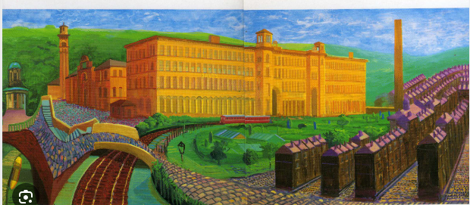  ART: This is David Hockney’s picture of Saltiare - you can make a model of it or do your own.

