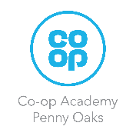 Year 1 Homework

Please complete a minimum of two task per half term. To be returned by 17th December 2024. You may present your work in any way that you wish. We look forward to seeing some of your amazing creations! Have fun!

|  |  |
| --- | --- |
| **Task Options** | |
| Make a map of the United Kingdom. | Create your own leaf monster using Autumnal leaves. |
| Create your own story book about a prince or princess and a dragon. | Draw a map of our school. |