Year 2 Homework
Please complete a minimum of one task per half term. To be returned by Monday 2nd December 2024.
You may present your work in any way that you wish. We look forward to seeing some of your amazing creations! Have fun!
Task Options
Make a 3D model Amelia’s Earhart plane (Canary). Try to use recycled materials for this project. Label parts of your aeroplane.  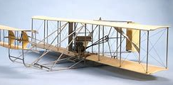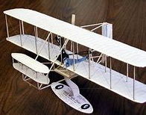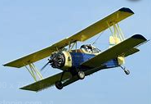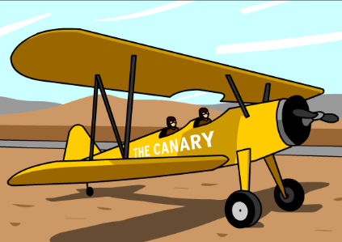 | Choose one animal from the four animal groups (birds, fish, mammals and amphibians) and describe it.  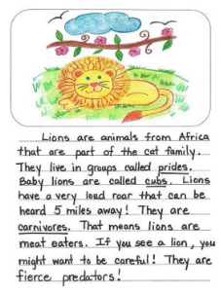
Write an adventure story that includes some means of transport. Make sure your writing includes capital letters, full stops, conjunctions (and because when that so or but) and adjectives. | Create a WANTED letter for Amelia Earhart. Include as much information as you can.  
If you need any resources please ask.

