Year 2 Homework
Please complete a minimum of one task per half term. To be returned by Monday 10th January 2025.
You may present your work in any way that you wish. We look forward to seeing some of your amazing creations! Have fun!
Task Options
Draw your own map of UK. Remember to label all of the UK countries and the surrounding seas.  Go big with your map!  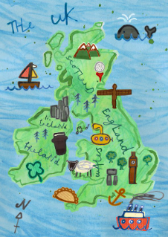 | Make a building (house, shop, church, mosque, temple or any other building you have seen in Bradford) using any material you want. Plastic, cardboard or wood would be the most sensible choices  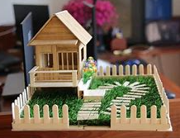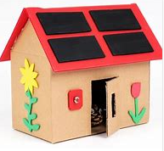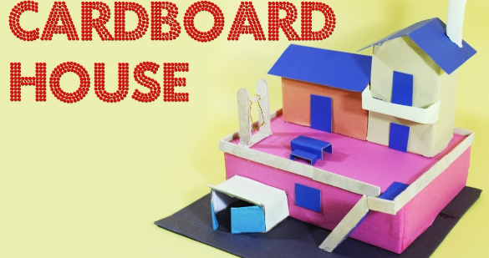
Make a leaflet of a city or a place you have visited in UK.  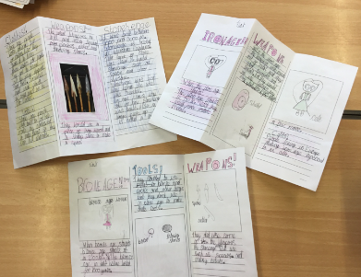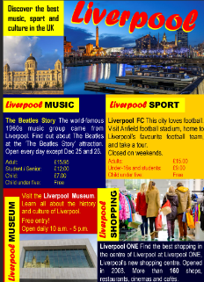 | Write down a story based in the city (It could even be Bradford!)  Think about your characters, setting and the problem in the story.  Please remember to use capital letters, full stops, conjunctions, adjectives and yor most gorgeous handwriting
If you need any resources please ask.

