Task Options
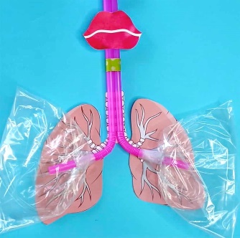  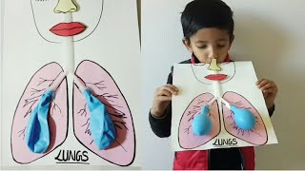  SCIENCE: google and make a lung model | 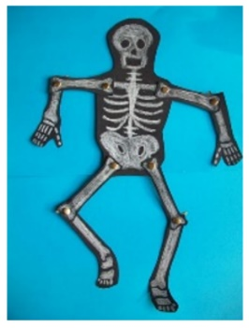  SCIENCE: google and make a model of a human skeleton. Can you name any of the bones?
GEOGRAPHY: can you make a model of the earth, labelling the following sections: equator, latitude and longitude  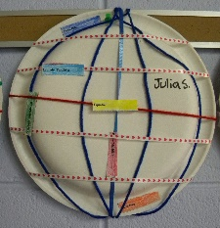 | GEOGRAPHY: Research a country in the tropics and write a postcard from there
RE: think about a miracle you would like to happen to make the world a better place. Create a piece of art or make a poster to show this miracle | ART: can you replicate one of Linda Mackey’s artwork

