**Curriculum pathway:**

**Key Vocabulary:**

Carving – Cutting into or shaping solid materials such as wood

Lino print –A form of block printing that involves carving a pattern or design into a linoleum, rubber or vinyl surface that can then be printed from.

Negative space – The space around and between the subject of an image.

Block ink - A special type of ink used for block printing, a creative technique where a design is carved into a block, typically made of wood or linoleum.

**Art Year 6**

**Summer Term – Back to Our Roots**

**Lino print project**

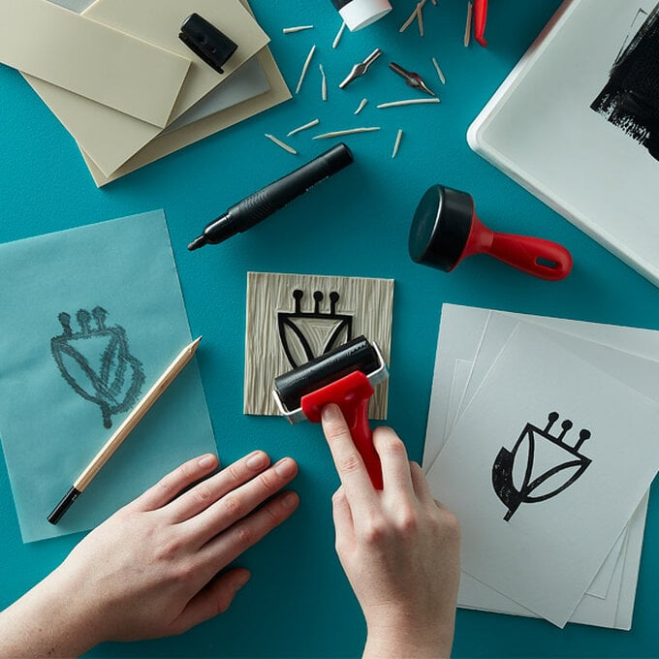

**Key Questions:**

What did Viking art look like?

What materials did the Vikings use to create works of art?

What can we learn about the Vikings from their art?

**Key Facts:**

Vikings made excellent wood and metalwork.

They made intricate designs on silver or wood to make brooches and other jewellery.

Their silver metalwork was used as jewellery and other objects for decoration by the rich and powerful in Scandinavia.