**Curriculum pathway:**

**Art Year 4**

**Summer Term – The Great Escape**

**Michelangelo (Sculptures)**

**Key Vocabulary:**

Sculpt - to shape or carve a figure out of a mouldable or hard material

Carve - using tools to shape something from a material by scraping away portions of that material

Score - to scratch marks on clay to join it to another piece of clay

Slip - Liquid clay

Casting - a technique that involves using a mould to make a sculpture

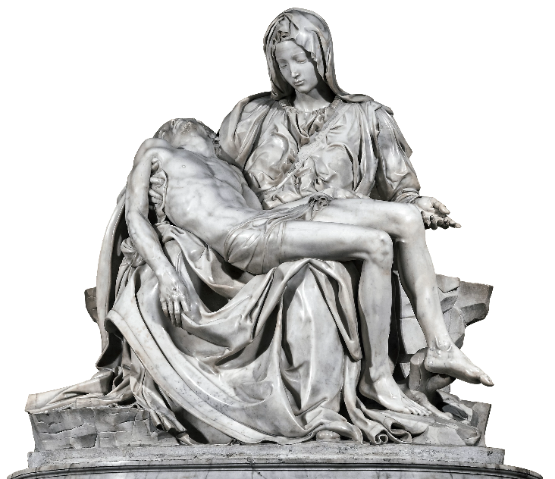

**Key Questions:**

Why is Michelangelo well-known?

What is a sculpture?

How can we join clay to make a sculpture?

**Key Facts:**

Michelangelo was an Italian artist.

He is most famous for the sculpture of David and Pieta.

Sculptors use four basic processes - carving, modelling, casting and constructing - to create their works.

We can use printing to create repeated or reoccurring patterns.