**Key Vocabulary:**

Silhouette – The dark shape and outline of someone or something

Form – The shape of something in three dimensions

Wet/dry media - A dry medium leaves a mark made of small matter that can be rubbed or blended by smudging. A wet medium uses pigment in liquid, perhaps water or alcohol.

**Art Year 6**

**Autumn Term – Fighting Fit**

**Richard Eurich**

**Curriculum pathway:**

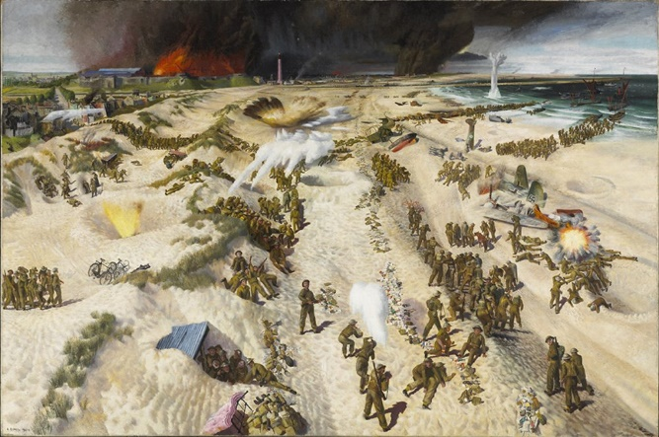

**Key Facts:**

Richard Eurich was born in Bradford

Richard Eurich worked as a war artist to the Admiralty in the Second World War.

**Key Questions:**

Why do artists use different materials?

What is the effect of using different textures?