**Key Vocabulary:**

Cityscape - an artist’s picture of a city

Skyline - the line where earth and sky or water and sky seem to meet

Illustrator - an artist who draws the pictures in a book

**Curriculum pathway:**

**Art Year 2**

**Spring Term – My Country, My City**

**Local area art – Cityscapes**

**Mick Manning**

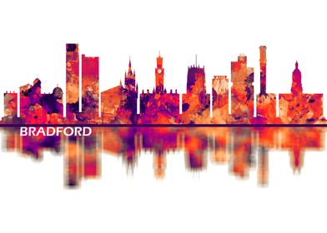

**Key Questions:**

Who is Mick Manning?

What does an illustrator do?

What is a cityscape?

What is a skyline?

**Key Facts:**

**Mick Manning** was born in Haworth.

Mick Manning is an illustrator.