**Key Vocabulary:**

Impressionism - a style of painting which began in France in the 1860s.

Seascape - a view of the sea

Landscape – a view of the land

**Curriculum pathway:**

**Art Year 1**

**Spring Term – Eco-Warriors**

**Seascapes**

**Van Gogh**

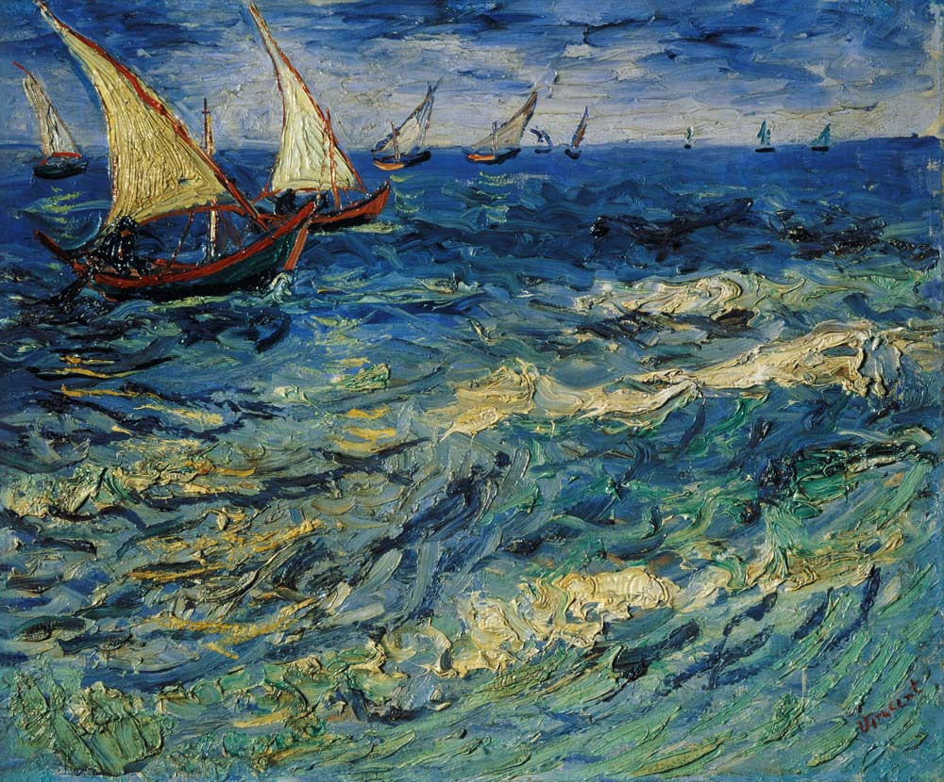

**Key Facts:**

Vincent Van Gogh was a famous Dutch painter.

Van Gogh was one of the greatest post-impressionists.

Van Gogh used bold, dramatic brush strokes and bright colours

A seascape is a picture representing a scene at sea.

**Key Questions:**

Who was Vincent Van Gogh?

What is Van Gogh famous for?

What kind of painting style did Van Gogh have?

What is a seascape?