**Curriculum pathway:**

**Key Vocabulary:**

Line Drawing – a drawing made in solid lines

Texture - the way an object looks as it may feel if it were touched

Background - the part of a painting that lies behind objects in the foreground

Foreground - the part of a painting that lies in front of objects in the background

Contemporary - art made and produced by artists from 1970 up to the present day

Monochrome – A picture made up of varying tones of only one colour

Tone – how light or dark a colour is

**Art Year 3**

**Autumn Term – Who First Lived in Britain?**

**Stone age art**

**Ismael Gulgee**

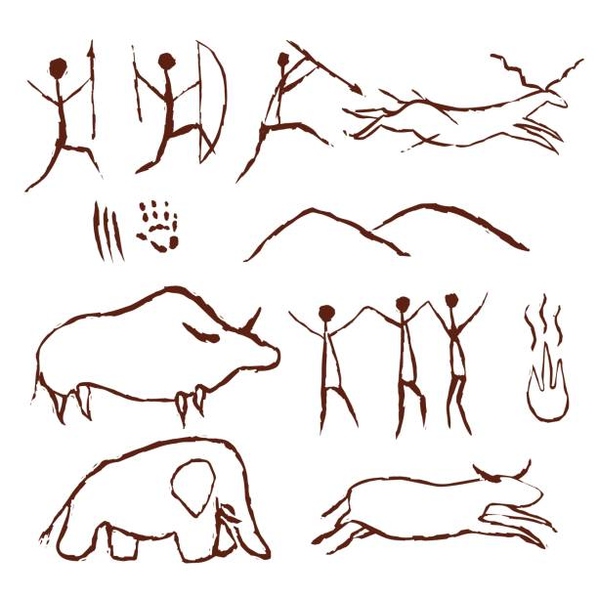

**Key Facts:**

Cave paintings are prehistoric works of art created by Stone Age people.

Cave paintings often show pictures of animals and sometimes humans or human handprints.

Stone Age people did not have paint so they natural resources for their paintings.

Ismail Gulgee was a contemporary Pakistani painter and sculptor.

**Key Questions:**

What are cave paintings?

What materials did Stone Age people use to create their cave paintings?

Who is Ismail Gulgee?