**Key Vocabulary:**

Impressionism – A style of painting that focus on the effects of light and atmosphere on colours and objects

Expressionism – A art and cultural movement of the 20th Centaury

**Curriculum pathway:**

**Art Year 6**

**Spring Term – Journeys**

**Claude Monet**

**Papier Mache**

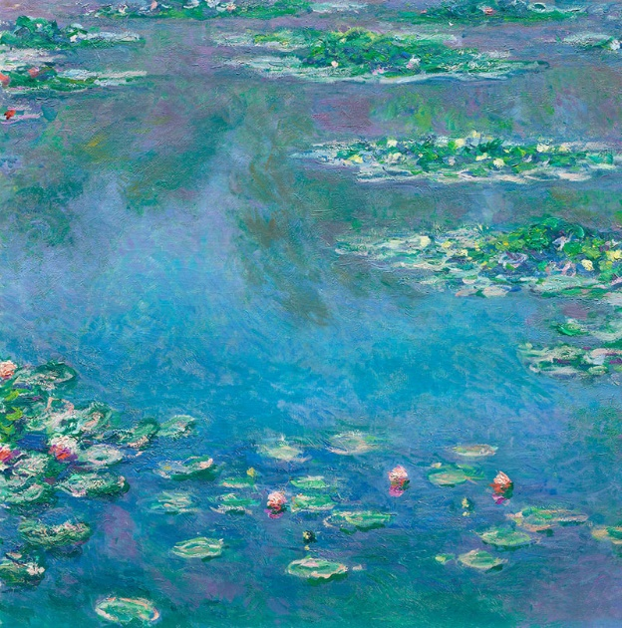

**Key Facts:**

Monet was the leading French Impressionist landscape painter.

**Key Questions:**

What was Claude Monet famous for painting?

What is impressionism?

What is expressionism?