**Curriculum pathway:**

**Key Vocabulary:**

Secondary colour – A colour resulting from the mixture of two primary colours

Colour wheel – A circle with different coloured sections used to show the relationship between colours

Complimentary – Colours that are opposite each other on the colour wheel

Neutral – Pale grey, cream or beige

High chroma – Strong or vivid colour

**Art Year 5**

**Autumn Term – Adventures**

**John Sargent/Georgia O’Keeffe**

**Watercolours/ Oil pastels**

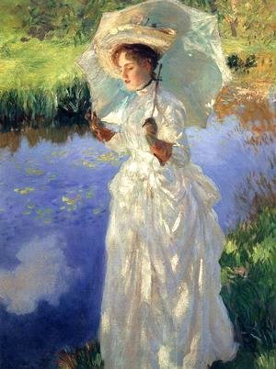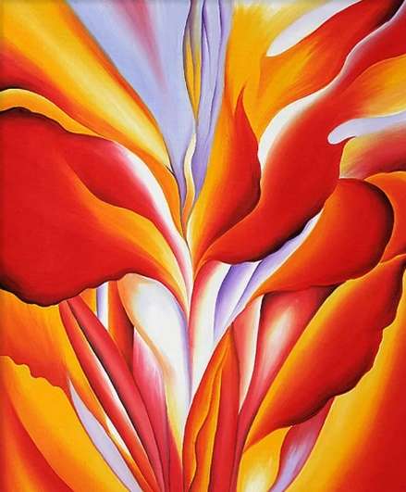

**Key Facts:**

Georgia O’Keeffe became the first female painted to gain respect in New York’s art world in the 1920s

John Sargent is an American artist/watercolourist known for his landscapes and portraits.

**Key Questions:**

How are watercolours best used?

Why is it important to plan your artwork?

Why is imagination important in art and design?

What colours are on the colour wheel?

How do you make secondary colours?