**Curriculum pathway:**

**Art Year 5**

**Spring Term – Beautiful Britain**

**Stephen Wiltshire**

**Key Vocabulary:**

Refining – Improving an idea

Technique – A method of doing an activity

Style – The manner in which an artist portrays their work of expresses their vision

Monochrome – Only includes one colour

Medium – The substance used to create a piece of art

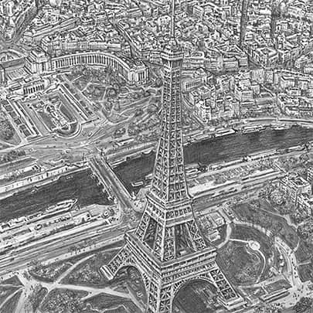

**Key Facts:**

Stephen Wiltshire draws landscape from memory.

Stephen Wiltshire has an MBE

**Key Questions:**

What is Stephen Wiltshire famous for?

Why do artists experiment with different mediums?

What is landscape art?