**Curriculum pathway:**

**Key Vocabulary:**

Pop Art - a style of art based on simple, bold images of everyday items painted in bright colours

Perspective - an organized event in which a collection of art can be viewed by the public

Exhibition - creates a realistic impression of depth

**Art Year 4**

**Autumn Term – Our Magical City**

**David Hockney**

**Saltaire – Sketching**

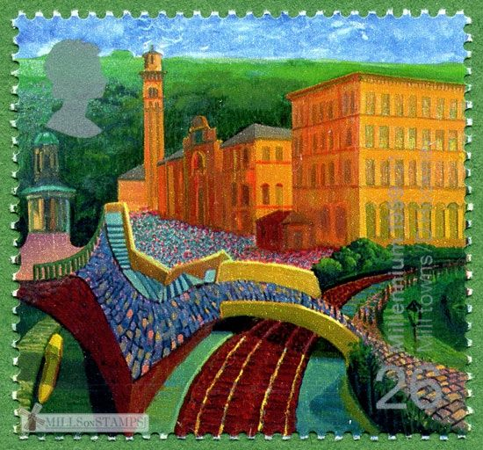

**Key Questions:**

How do we create texture?

What is Pop Art?

How can we create perspective?

**Key Facts:**

David Hockney is an artist from Bradford.

David Hockney uses Ipads to create art.