**Curriculum pathway:**

**Key Vocabulary:**

Renaissance - a period of time from the 14th to the 17th century in Europe

Relief tile - A sculpture on a flat surface

**Art Year 2**

**Autumn Term – History of Flight**

**Leonardo Da Vinci**

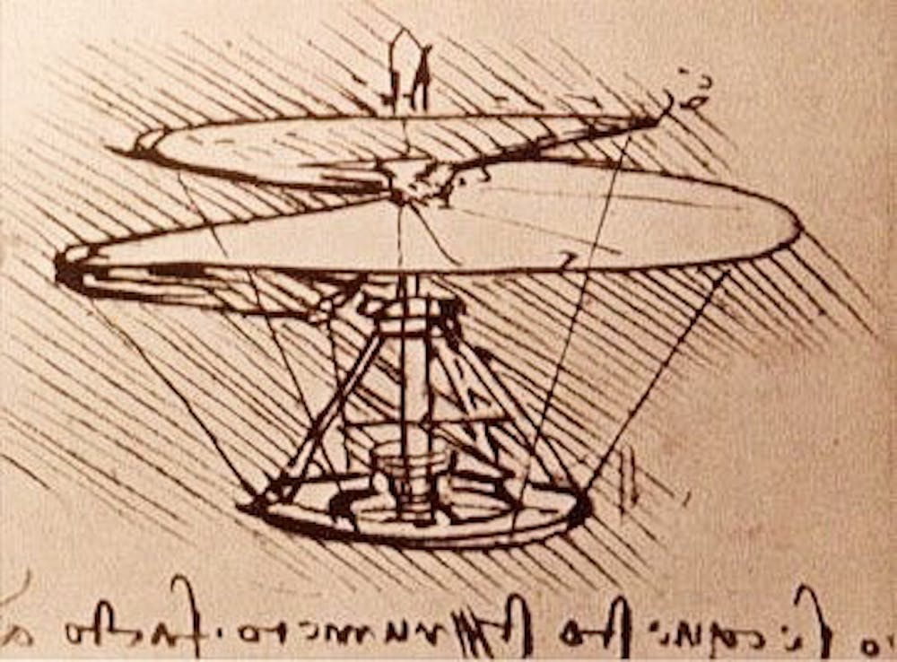

**Key Facts:**

Leonardo da Vinci was an Italian artist, engineer, sculptor and architect.

**Key Questions:**

Who was Leonardo Da Vinci?

What is a sketchbook?

What is a textured relief tile?