**Key Vocabulary:**

Urban landscape –An outdoor environment that is dominated by urban features. This includes both man-made and natural elements found in an urban area such as buildings, roadways, parks, and other elements that are present in a city or town.

Modroc - A **fabric bandage coated in plaster of Paris**

Perspective landscape – A technique used to give the impression of **depth on a flat surface.**

**Curriculum pathway:**

**Art Year 5**

**Summer Term – The Industrial Age**

**L.S Lowry**

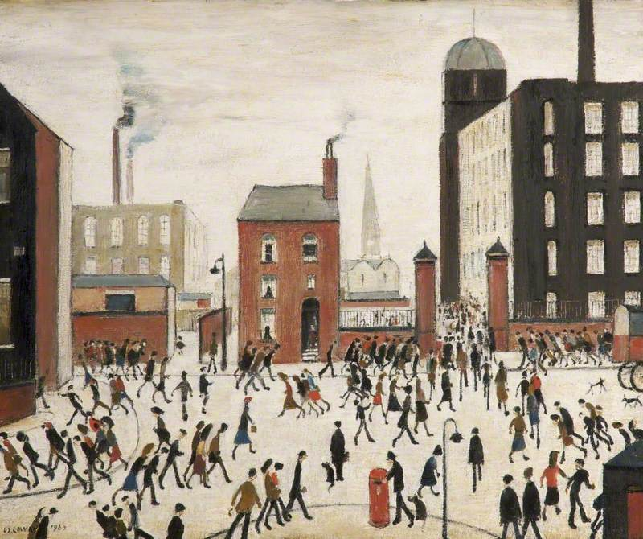

**Key Facts:**

L.S Lowry created paintings with matchstick men using a few simple colours.

Lowry is well known for being a reclusive person.

**Key Questions:**

What colours does Lowry use in his paintings?

What is Lowry known for painting?