**Curriculum pathway:**

**Key Vocabulary:**

Variable - something that can be changed

**Computing Year 5**

**Autumn 1**

**Computer Science**

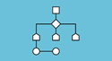

**Key Facts:**

Variables can change.

**Key Questions:**

What do we use variables for?