**Curriculum pathway:**

**DT Year 2**

**Autumn Term – History of Flight**

**Preparing a healthy snack**

**Flapjacks and seed bars**

**Key Vocabulary:**

Hygiene - Hand-washing, bathing, toileting, cleaning teeth, blowing noses and more

Safety - Anything that people do to protect themselves or others from harmful accidents

Ingredients – The different parts of a mixture

Seeds - The small parts produced by plants from which new plants grow

Oats - A type of cereal grain

Golden syrup – A *sweet* thick and amber-coloured liquid

Butter - A dairy product made from fat and protein

Brown sugar - Soft sugar that is covered by dark syrup

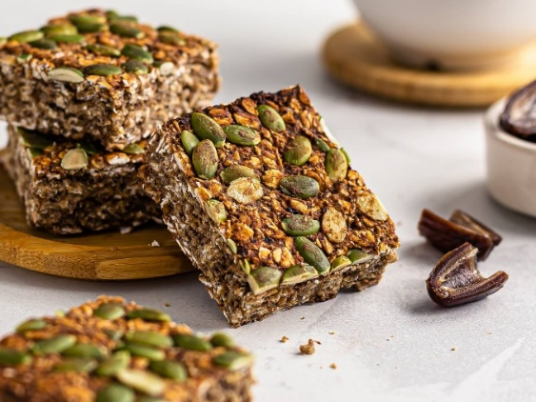

**Key Questions:**

What is a flapjack?

What is a seed bar?

Where do seeds come from?

Where do oats come from?

What is a recipe?

How can we cook and prepare flapjacks/seed bars?

How can we be safe and hygienic while cooking/handling food?

**Key Facts:**

Seeds come from the inside of flowers and fruits.

Oats are the edible seed of oat grass

The word flapjack is believed to come from flipping or flapping a cake on a griddle pan.

Seeds are a good source of protein

Eating seeds everyday helps to keep your body healthy