**Curriculum pathway:**

**Key Vocabulary:**

Slider – A rigid bar which moves backwards and forwards along a straight line

Lever - A rigid bar that moves around a pivot

Motion - The change of position of an object

Pivot - Point about which a lever turns

Linear - When an object moves in a straight line

Curved – A smooth flowing line without any sharp turns and that bends

**DT Year 1**

**Autumn Term – Castles**

**Sliders and Levers**

**Cook a Royal Feast**

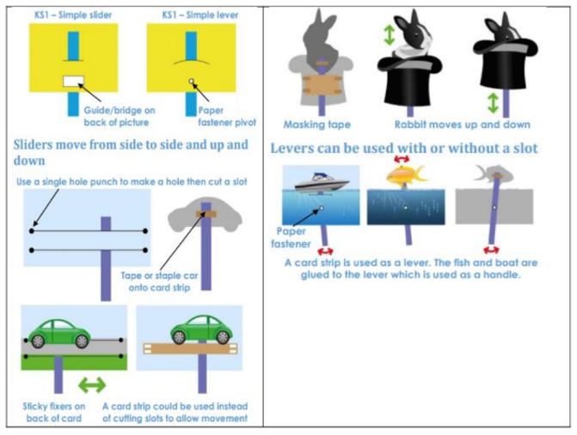

Experiences

**Key Facts:**

A slider moves in a linear motion.

A bridge secures the slider and controls its movement

A lever moves in a curved motion

A lever moves on a pivot

Some reasons we give cards are for special occasions (e.g. Christmas, birthdays, Valentines etc.), to congratulate someone or to say get well soon.

**Key Questions:**

What are sliders and levers?

Why do we send/give people cards?

How can we make parts of our designs move?