**Key Vocabulary:**

Sandwich - Two pieces of bread with food such as cheese, salad, or meat between them

Pitta - A kind of flat bread

Tortilla Wrap - A type of flatbread

Filling - A food mixture that is used to fill something

Carbohydrates - The body's major source of energy

Protein - Protein also helps to build a healthy immune system

Dairy - Foods produced from the milk of mammals, such as cows and goats

Oils - Fat of a plant or animal which is liquid at room temperature and is suitable for food use.

Fibre - The part of plant food which is not broken down completely by our bodies

Nutrition - The study of food and how it works in your body

**Curriculum pathway:**

**DT Year 3**

**Summer Term – Greeks**

**Savoury dish**

**Make a Greek Salad**

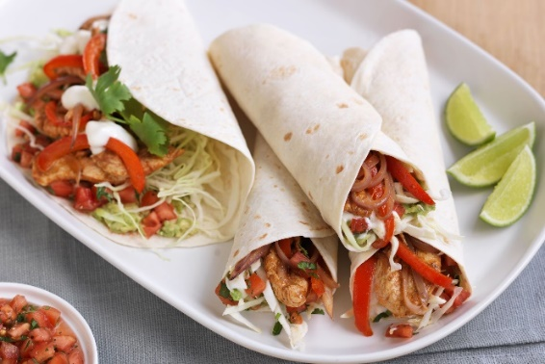

**Key Facts:**

Fajitas are a Mexican dish consisting on ingredients encased in a tortilla wrap

Pitta bread is a healthy alternative to sliced bread with more vitamins, minerals and fibre

Food can be sorted into the following groups:

Fruit and Vegetables

Carbohydrates

Protein

Dairy

Spread and Oils

A balanced diet consists of all the different groups but too much of some would be unhealthy

**Key Questions:**

What types of food are considered healthy?

What are the different food groups?

Why do we use bread to contain ingredients?

Why are some ingredients suited to sandwiches more than others?

How do we prepare ingredients for a sandwich?