**Curriculum pathway:**

**Key Vocabulary:**

Badge - A mark or sign worn to show that a person belongs to a certain group

2D - Shapes with two dimensions, such as width and height

3D - Shapes are measured by length, width and depth

Needle - A small, pointed piece of metal that's used in sewing

Running Stitch - A small even stitch run in and out in cloth

Back Stitch - A basic hand stitch where the thread is sewn in a back and forward way

Cross Stitch - Uses little crosses to create a tiled pattern or design

**DT Year 3**

**Spring Term – Here, There and Everywhere**

**2D to 3D**

**Create a balanced diet**

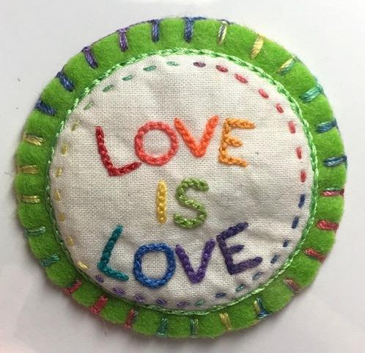

**Key Facts:**

A badge is a small piece of metal or fabric with a design on it

They are used for uniforms to show membership of a group

We can use running stitch, back stitch and cross stitch to join materials together

Each type of stitch has advantages and disadvantages

The eye of the needle is the place we push our thread through to join it

To finish a stitch we tie a knot

2D means an object only has a width and length. 3D also has a height

**Key Questions:**

What is a badge?

What different types of stitch can we use?

What materials would work well for a badge?

How do we begin and finish a stitch?