**Curriculum pathway:**

**DT Year 3**

**Autumn Term – Stone Age**

**Levers and linkages**

**Create a meal with low food miles**

**Key Vocabulary:**

Linkage - Joined to one or more levers to provide movement

Input - An action that is done to a mechanism

Output - The action that is the result of the input

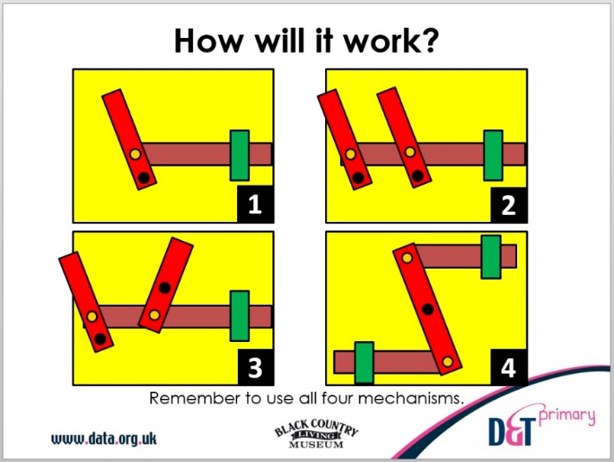

**Key Facts:**

Bridges are used to control the motion of a mechanism

A lever mechanism can have multiple pivots

**Key Questions:**

How does a lever work?

How do levers and linkages work together?

What are the best levers to use?

What are the best linkages to use?